Sethatevy Bong

CMSC 203

Lab 3

Task #1

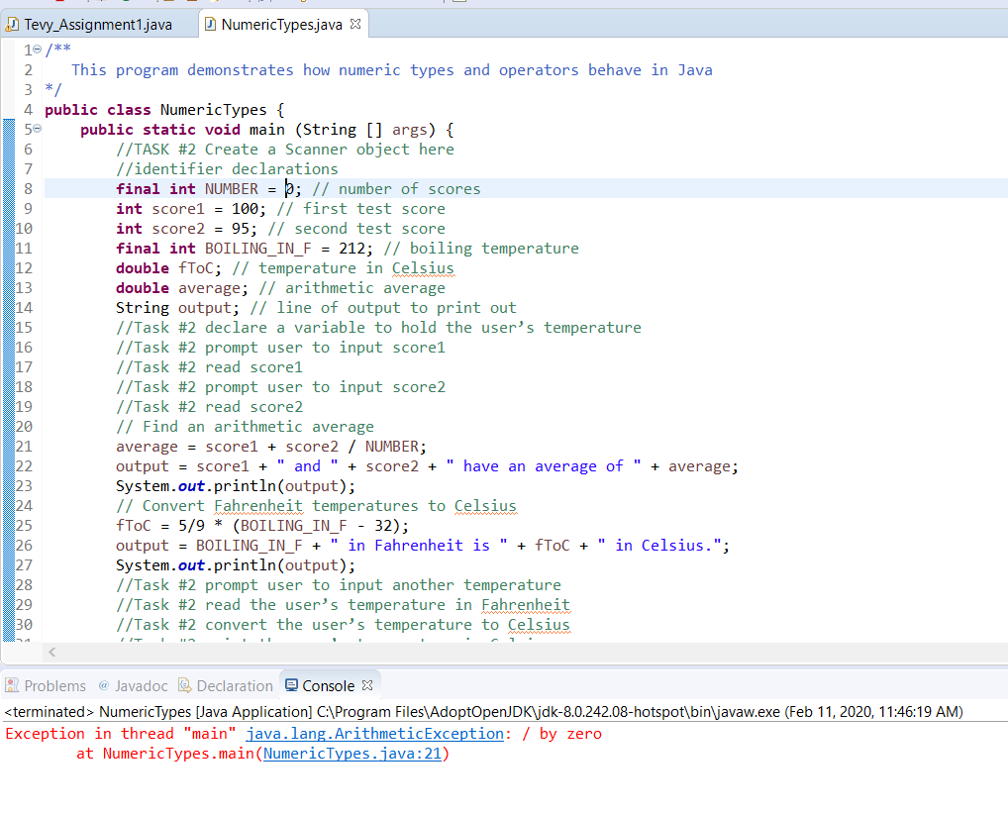

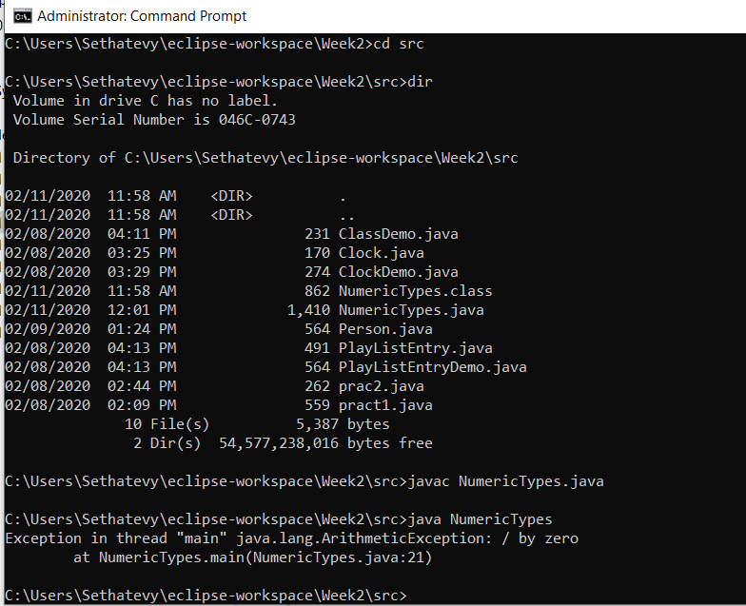

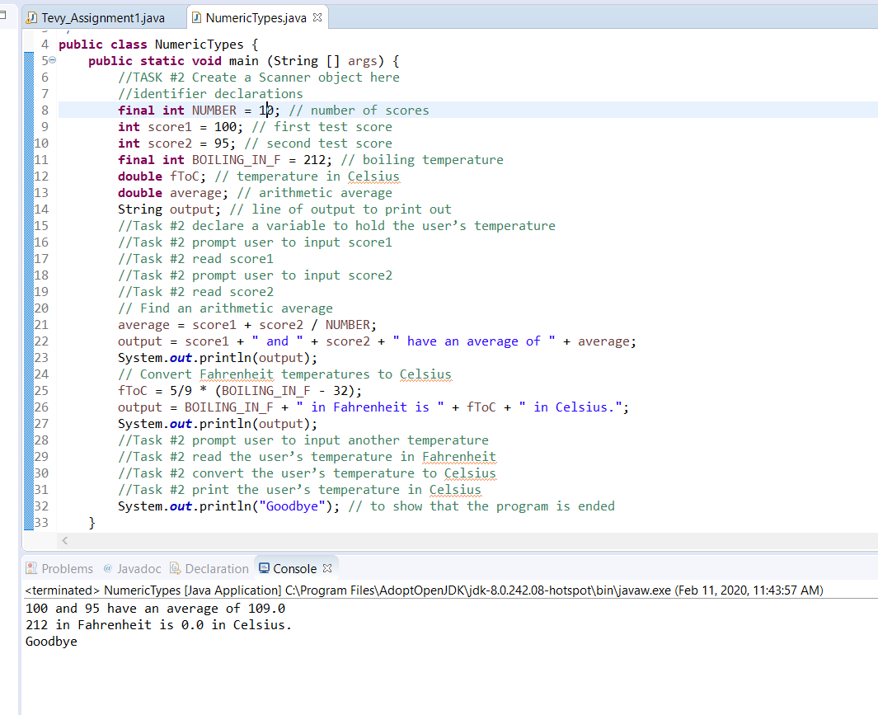

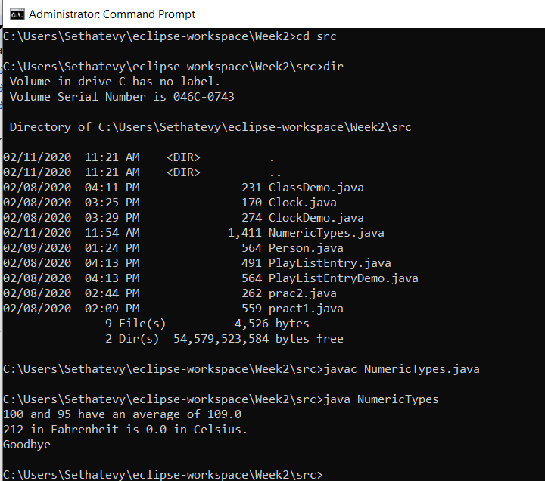

Task#3

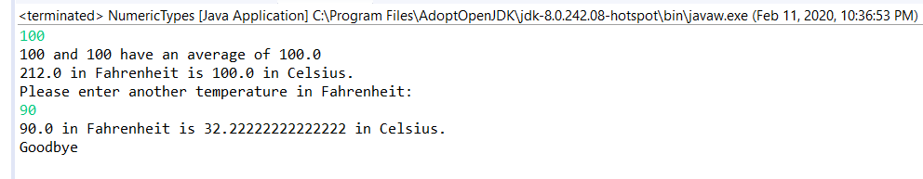

|  |  |  |
| --- | --- | --- |
| Diameter | Volume (hand calculated) | Volume (resulting output) |
| 2 | 4.1887902047863905 | 4.1887902047863905 |
| 25.4 | 8580.246646 | 8580.24664605096 |
| -5 | -65.44984695 | -65.44984694978736 |

#Task4

